**MARTIN MAINA**

**Python Basics:**

**What is Python, and what are some of its key features that make it popular among developers? Provide examples of use cases where Python is particularly effective.**

### What is Python, and What are Some of Its Key Features?

**Python** is a high-level, interpreted programming language known for its readability and simplicity. It is widely used for various types of software development due to its versatility and ease of use.

**Key Features of Python:**

1. **Readability**: Python's syntax is designed to be easy to read and understand, making it an excellent choice for beginners.
2. **Versatility**: Python supports multiple programming paradigms, including procedural, object-oriented, and functional programming.
3. **Extensive Libraries**: A rich standard library and a vast ecosystem of third-party packages available through the Python Package Index (PyPI).
4. **Interpreted Language**: Python code is executed line by line, which makes debugging easier and faster.
5. **Cross-Platform**: Python runs on various operating systems, including Windows, macOS, and Linux.
6. **Community Support**: A large and active community contributes to Python’s development, documentation, and support.

**Examples of Use Cases Where Python is Particularly Effective:**

1. **Web Development**: Frameworks like Django and Flask enable rapid development of web applications.
2. **Data Analysis and Visualization**: Libraries such as Pandas, NumPy, and Matplotlib are widely used in data science.
3. **Machine Learning and AI**: Libraries like TensorFlow, Keras, and scikit-learn make Python a popular choice for machine learning projects.
4. **Automation and Scripting**: Python is commonly used for automating repetitive tasks and writing scripts for various applications.
5. **Scientific Computing**: Libraries like SciPy and SymPy are used for scientific and mathematical computations.
6. **Game Development**: Libraries such as Pygame allow for the creation of simple games and multimedia applications.

### Installing Python

**Steps to Install Python on Various Operating Systems:**

#### Windows:

1. **Download Python Installer**:
   * Go to the [official Python website](https://www.python.org/downloads/" \t "_new) and download the latest version of Python.
2. **Run the Installer**:
   * Open the downloaded installer.
   * Check the box that says "Add Python to PATH."
   * Click "Install Now."
3. **Verify the Installation**:
   * Open Command Prompt and type python --version or python3 --version.
   * You should see the version number of the installed Python.
4. **Set Up a Virtual Environment**:
   * Open Command Prompt.
   * Navigate to your project directory.
   * Run python -m venv venv to create a virtual environment named venv.
   * Activate the virtual environment by running venv\Scripts\activate.

#### macOS:

1. **Install Homebrew (if not already installed)**:
   * Open Terminal and run:

sh

Copy code

/bin/bash -c "$(curl -fsSL https://raw.githubusercontent.com/Homebrew/install/HEAD/install.sh)"

1. **Install Python**:
   * Run brew install python.
2. **Verify the Installation**:
   * Open Terminal and type python3 --version.
   * You should see the version number of the installed Python.
3. **Set Up a Virtual Environment**:
   * Open Terminal.
   * Navigate to your project directory.
   * Run python3 -m venv venv to create a virtual environment named venv.
   * Activate the virtual environment by running source venv/bin/activate.

#### Linux:

1. **Install Python**:
   * Open Terminal.
   * On Debian-based systems (like Ubuntu), run:

sudo apt update

sudo apt install python3 python3-venv python3-pip

1. **Verify the Installation**:
   * Open Terminal and type python3 --version.
   * You should see the version number of the installed Python.
2. **Set Up a Virtual Environment**:
   * Open Terminal.
   * Navigate to your project directory.
   * Run python3 -m venv venv
   * Activate the virtual environment by running source venv/bin/activate.

**Data Types and Variables in Python**

Python has several built-in data types. Here are some of the basic ones:

1. **Integer (int)**: Represents whole numbers.
2. **Float (float)**: Represents floating-point numbers (numbers with a decimal point).
3. **String (str)**: Represents text data.
4. **Boolean (bool)**: Represents truth values, either True or False.
5. **List (list)**: Represents a collection of items that can be of different types.
6. **Tuple (tuple)**: Similar to lists but are immutable (cannot be changed).
7. **Dictionary (dict)**: Represents a collection of key-value pairs.
8. **Set (set)**: Represents an unordered collection of unique items.

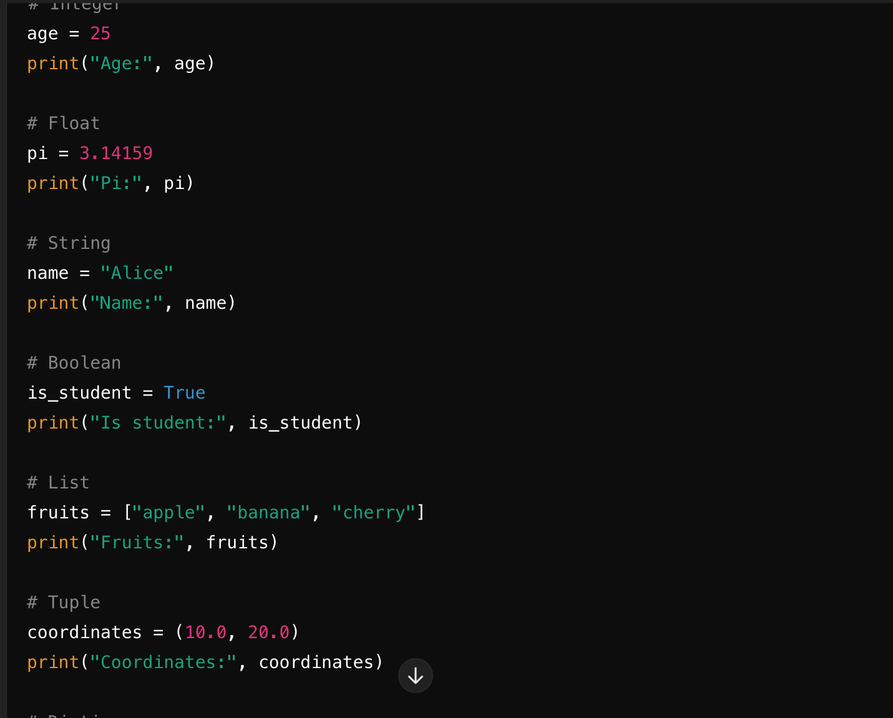

### Control Structures

Control structures in Python allow you to control the flow of your program. The main control structures are conditional statements and loops.

**Conditional Statements:**

Conditional statements allow you to execute certain code based on whether a condition is true or false.

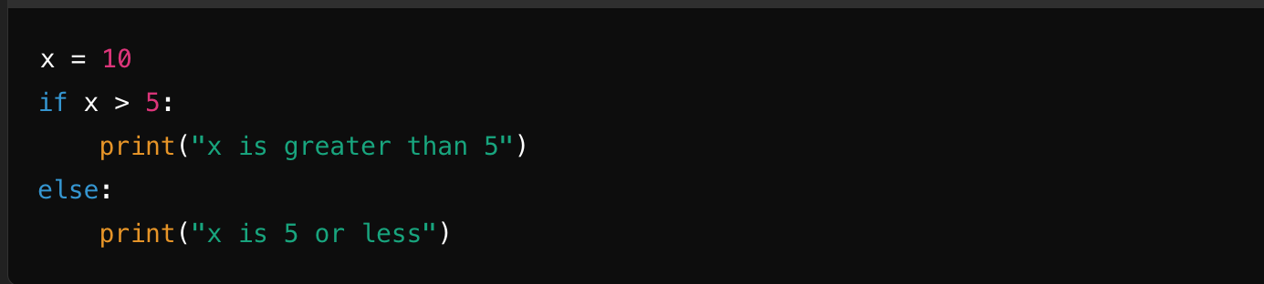

**Loops:**

Loops allow you to execute a block of code multiple times. The most common loops in Python are for loops and while loops.

Example of a for loop:

for i in range(5):

print("Iteration:", i)

### Functions in Python

Functions are reusable blocks of code that perform a specific task. They help in organizing code, making it more readable, and reducing redundancy.

Here's a simple function that takes two arguments and returns their sum:

def add\_numbers(a, b):

return a + b

result = add\_numbers(3, 5)

print("Sum:", result)

**Lists and Dictionaries**

**Lists** and **dictionaries** are both data structures in Python, but they have some key differences:

* **Lists**: Ordered collections of items, which can be of any type. Items are accessed by their position (index) in the list.
* **Dictionaries**: Unordered collections of key-value pairs. Keys are unique and are used to access the corresponding values.

Here’s a script demonstrating basic operations on lists and dictionaries:

# Creating a list of numbers

numbers = [1, 2, 3, 4, 5]

print("List of numbers:", numbers)

# Basic list operations

numbers.append(6) # Adding an element to the end of the list

print("After appending 6:", numbers)

numbers.remove(3) # Removing an element from the list

print("After removing 3:", numbers)

print("Second element in the list:", numbers[1]) # Accessing an element by index

# Creating a dictionary with key-value pairs

person = {"name": "Alice", "age": 30, "city": "New York"}

print("Dictionary:", person)

# Basic dictionary operations

person["email"] = "alice@example.com" # Adding a new key-value pair

print("After adding email:", person)

del person["age"] # Removing a key-value pair

print("After deleting age:", person)

print("Name:", person["name"]) # Accessing a value by key

**Exception Handling**

Exception handling in Python allows you to handle runtime errors gracefully. The try block lets you test a block of code for errors. The except block lets you handle the error. The finally block lets you execute code, regardless of the result of the try- and except blocks.

Here’s an example:

try:

# Code that may raise an exception

result = 10 / 0

except ZeroDivisionError as e:

# Handling the exception

print("Error:", e)

finally:

# Code that will run no matter what

print("This will always execute")

**Modules and Packages**

Modules and packages help you organize your Python code into manageable parts.

* **Module**: A single file containing Python code. You can define functions, classes, and variables in a module, and then import them into other scripts.
* **Package**: A collection of modules in a directory that includes a special \_\_init\_\_.py file.

To import and use a module, you can use the import statement. Here’s an example using the math module:

import math

# Using functions from the math module

print("Pi:", math.pi)

print("Square root of 16:", math.sqrt(16))

**File I/O**

Python provides built-in functions to read from and write to files.

**Reading from a file:**

# Reading the content of a file and printing it to the console

with open("example.txt", "r") as file:

content = file.read()

print(content)

**Writing to a file:**

# Writing a list of strings to a file

lines = ["Hello, world!", "Python is great.", "File I/O is easy."]

with open("output.txt", "w") as file:

for line in lines:

file.write(line + "\n")

**Reference:**

Lutz, M. (2013). Learning Python (5th ed.). O'Reilly Media.